PRESS RELEASE I Autumn 2025

Oliver moves in: Hygienic humidification made easy
Stadler Form launches an ultrasonic humidifier with UV technology

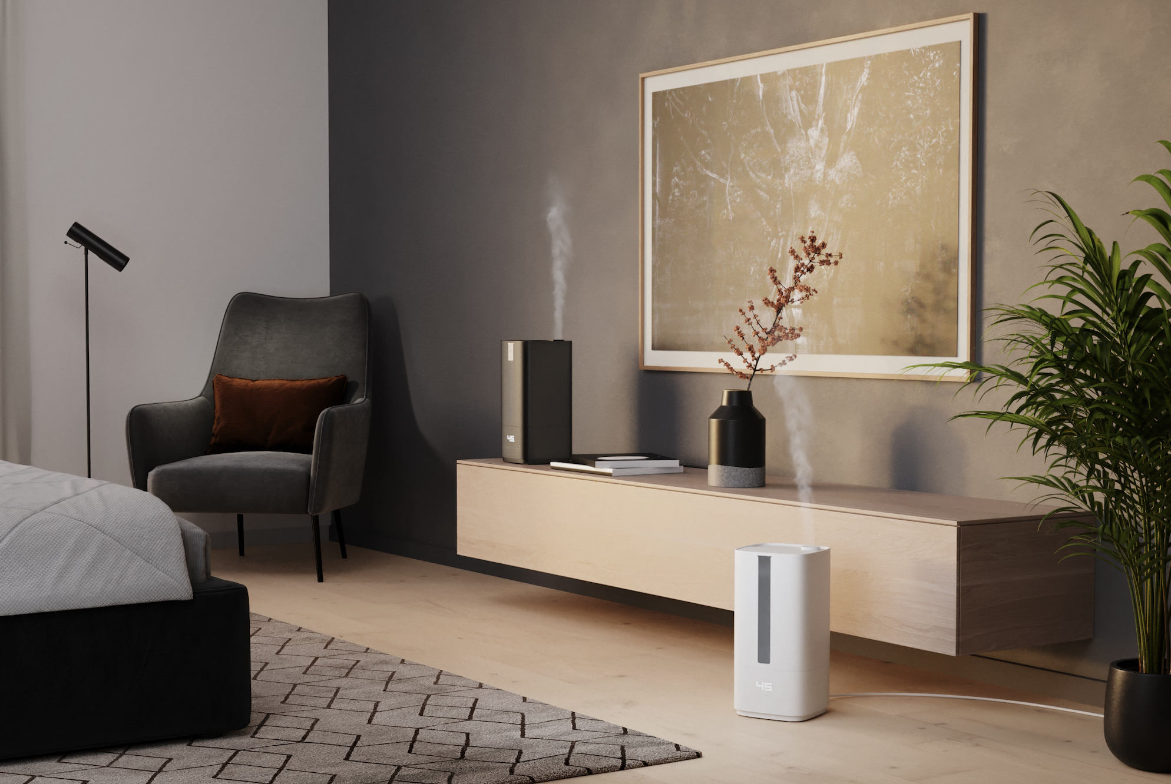

Dry air can negatively affect ones well-being and performance, especially in heated or air-conditioned indoor spaces. It strains the respiratory system and skin, may contribute to sleep disturbances, and reduce concentration. Therefore, a balanced indoor climate is crucial for daily comfort.
On August 26, Stadler Form is launching the new ultrasonic humidifier Oliver. His UV technology ensures germ-free humidification, he features easy water refilling even during operation, and offers the option to add essential oils for fragrance. Oliver is a helpful companion that also impresses with his stylish design in white and black.

“With Oliver, we are expanding our range with a product that sets new hygiene standards in air humidification,” says Martin Stadler, CEO of Stadler Form. “In collaboration with the Swiss designers Fabian Bernhard and Thomas Burkard, we have developed an all-rounder that blends functionality, user-friendliness and design. With UV technology, an integrated fragrance container, and his elegant appearance, Oliver meets these demands in every aspect.”

These features make Oliver the ideal helper for everyday use:

- Hygienic mist through UV technology

The integrated UV lamp disinfects the water before nebulisation, eliminating 99.99 % of all bacteria, viruses, and fungi. This produces an ultra-fine, hygienically pure mist that is released into the air — completely free of chemical additives.

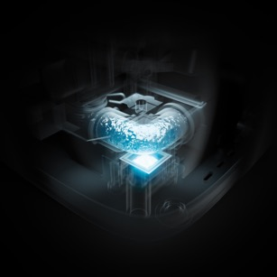

- Auto mode for efficient humidification

With his high humidification capacity, Oliver creates a comfortable indoor climate in rooms up to 60 m². The ultrasonic technology produces a fine mist that is directed precisely where needed through the flexibly adjustable outlet. Thanks to the auto mode, Oliver automatically adjusts the humidification level to quickly and energy-efficiently reach and maintain the desired humidity. The integrated hygrostat allows the target value to be set flexibly between 30 % and 75 % — with an optimal relative humidity for a healthy indoor environment falling between 40 % and 60 %.

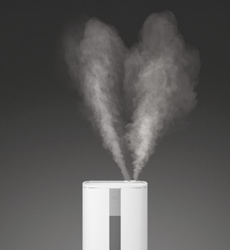

- Quiet operation and easy handling
Oliver is also ideal for the bedroom: on the lowest setting, he operates particularly quietly, and the LEDs can be completely switched off if desired – ensuring a peaceful, undisturbed night’s sleep. The water tank can be conveniently refilled from the top at any time, even during operation. Six individually selectable humidification levels and a programmable switch-off timer make him a flexible companion for everyday use. To maintain hygienic humidity, Oliver reminds you via the display to perform the next cleaning after 30 days. The automatic cleaning function helps make maintenance especially easy.

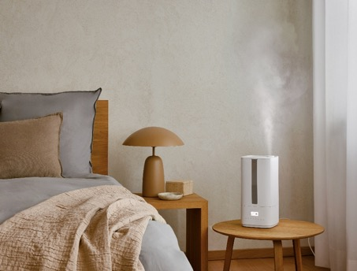

- Soothing fragrance and warm or cool mist

For added comfort, Oliver features an integrated fragrance container. Just a few drops of essential oil are enough to gently fill the room with a subtle aroma. Additionally, the built-in pre-heater warms the water if needed, causing the mist to evaporate faster and enhancing the humidification performance.

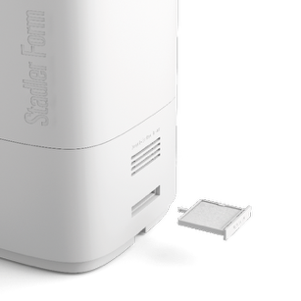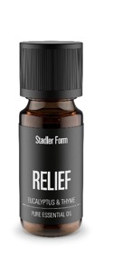
Humidifier Oliver in black and white from Stadler Form, current webshop price Fr. 109.–
Essential oil Relief from Stadler Form, current webshop price Fr. 9.90
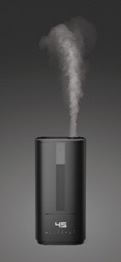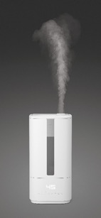
The new ultrasonic humidifier Oliver will be available starting from 26 August 2025 at
stadlerform.com and selected specialist retailers as well as their online shops.
Tip: Many houseplants release moisture through their leaves, helping to improve the indoor climate. However, during the winter months, this natural support is not sufficient enough to maintain a healthy indoor environment. Some plants even absorb moisture from the air. A humidifier is therefore the ideal addition, as it supports not only your own well-being but also the healthy growth of your green companions.

For more tips on the topic of humidifying the air, visit the Stadler Form blog at stadlerform.com/blog

Please do not hesitate to contact us for further information.

Media contact

Silvia Acerra
Flowcube Communications | E-Mail: silvia.acerra@flowcube.ch | | Tel. +41 (0)43 344 30 35

