PRESS RELEASE I Autumn 2025

Smart power for an optimal indoor climate
Stadler Form launches Noah & Noah Pro – powerful humidifiers for large rooms with app control.

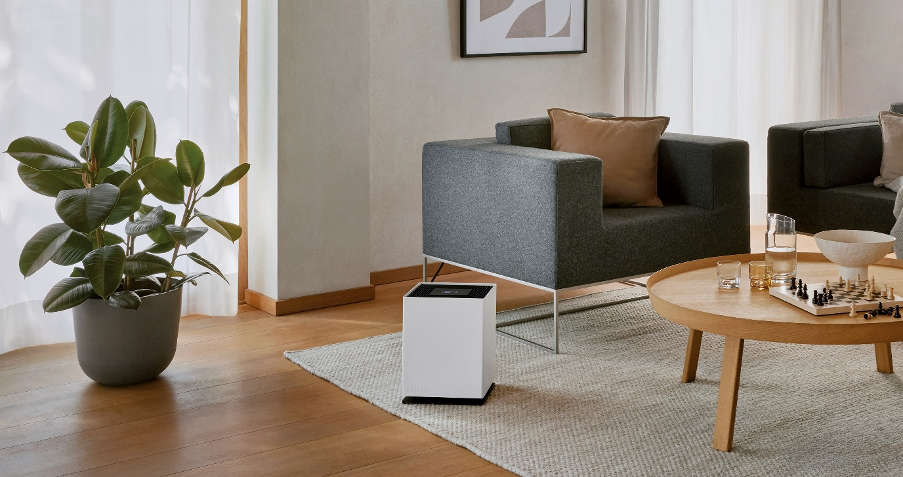

When temperatures drop outside and the heating is switched on, indoor air becomes noticeably drier, placing strain on the skin and mucous membranes, and increasing the risk of colds and infections. On 7 October 2025, Stadler Form will launch two new humidifiers: Noah and Noah Pro. Combining energy efficiency, powerful performance and timeless design, they are specifically designed for large rooms and the particular demands of energy-efficient homes with controlled ventilation, helping to create a healthy indoor climate, even in challenging conditions.

"Together with Swiss designer Matti Walker, we have further developed the successful Oskar and Karl families and are now proud to present Noah and Noah Pro. Thanks to valuable feedback from our customers, we were able to develop two devices that impress with innovation and performance," explains Martin Stadler, CEO of Stadler Form.

These features make Noah and Noah Pro the most advanced humidifiers:

- Powerful performance, even in large spaces

Noah and Noah Pro are designed to deliver maximum performance with minimal energy consumption. This makes them particularly energy-efficient and enables them to quickly increase humidity levels – even in large or high-ceilinged rooms. Noah is ideal for spaces of up to 110 m², while Noah Pro, with his professional-grade power, provides optimal humidification for living and working areas of up to 200 m². Thanks to his powerful humidification and energy-efficient technology, Noah Pro is also the perfect choice for well-insulated and mechanically ventilated spaces, such as passive houses or energy-efficient flats.

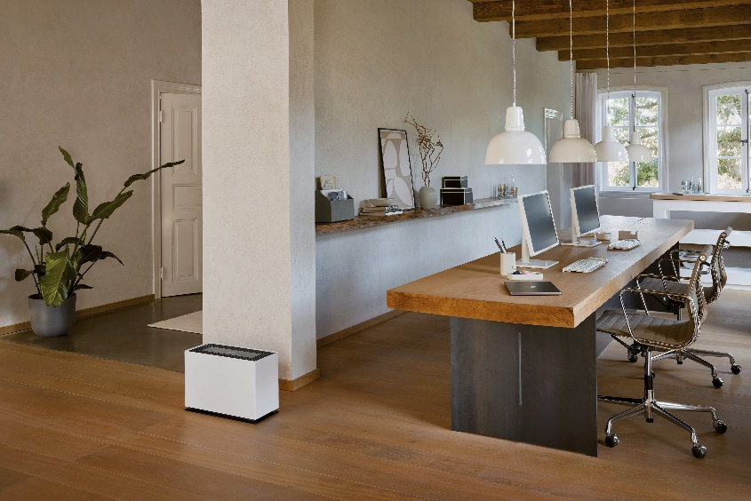

- Smart control via app

All functions – from selecting one of the four humidification levels to the automatic mode – can be conveniently controlled via the Stadler Form app. Current humidity levels and water level status can be checked at any time on the go. With just one click, Noah and Noah Pro switch to turbo mode for maximum humidification power, quickly creating the perfect indoor climate.
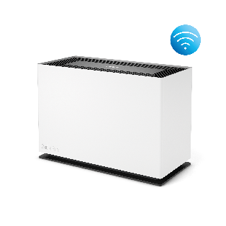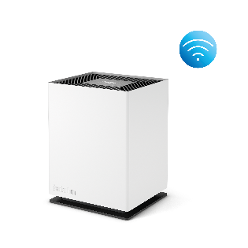

- Easy operation and quiet performance

Refilling the water is particularly easy: the tank can be filled even during operation via a side flap, with an automatic light indicating the water level. A digital hygrostat with auto mode ensures that the desired humidity level is reached quickly and maintained efficiently. After 60 days, a reminder function automatically notifies you to replace the filter, ensuring the device continues to operate efficiently. Noah and Noah Pro are also reliable companions in the bedroom. Both operate extremely quietly on low settings and, thanks to dimmable or switchable LEDs, allow for restful nights with optimal indoor climate.

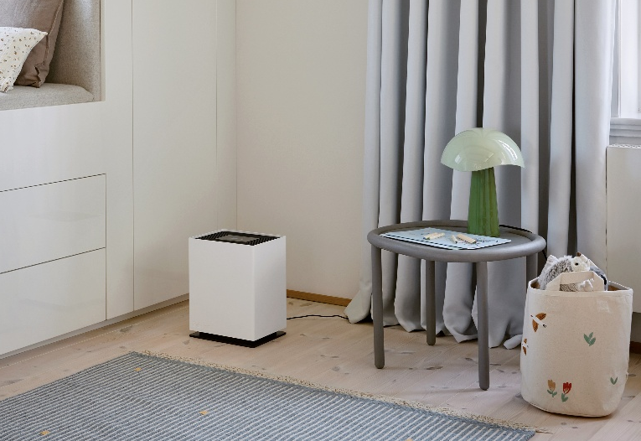

- Pleasant fragrance experience

Thanks to the integrated fragrance container, Noah and Noah Pro can gently scent the air when desired. Just a few drops of essential oil are enough to give the room a personal touch – calming or invigorating, depending on your choice.

Humidifier Noah in white from Stadler Form, current webshop price Fr. 169.-
Humidifier Noah Pro in white from Stadler Form, current webshop price Fr. 249.-
Essential oil Retreat from Stadler Form, current webshop price Fr. 9.90
The new Humidifiers Noah and Noah Pro will be available starting from 7. October 2025 at stadlerform.com and selected specialist retailers as well as their online shops. As part of the Pro Series, Noah Pro also comes with an extended five-year warranty.
Tip: Dry air affects not only the skin and mucous membranes but also materials such as wood. When humidity drops, wood loses moisture, shrinks, and may develop cracks. This can affect parquet floors, furniture, and musical instruments alike. Noah and Noah Pro maintain optimal humidity levels, helping to protect both your health and valuable furnishings in the long term.

More tips on the topic of humidifying the air can be found on the Stadler Form blog: stadlerform.com/blog

Please do not hesitate to contact us for further information.

Media contact

Silvia Acerra
Flowcube Communications | E-Mail: silvia.acerra@flowcube.ch | | Tel. +41 (0)43 344 30 35

