TRENDLETTER I Summer 2023

A fresh breeze for the summer

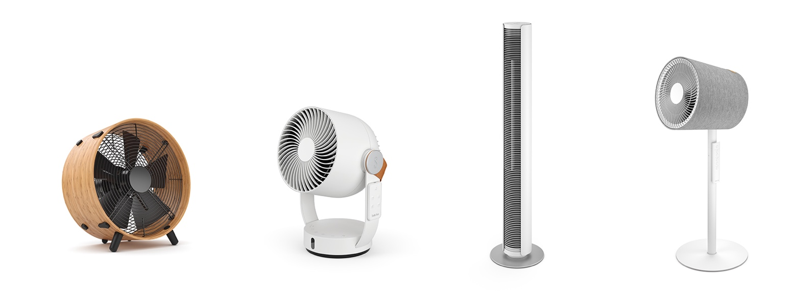
Keep it cool: Stadler Form presents the fans Otto, Leo, Peter and Simon

Cloudless skies, sunshine and warm temperatures outside equal a typical summer’s day. For many people summer is their favourite time of the year but everyone tolerates different levels of heat. What some people find to be comfortable is difficult for others to bear. Heat can raise tempers and cause problems with concentration and tiredness, especially at work or in the living room or bedroom. Stadler Form’s different types of fans are the perfect remedy in any setting because Otto, Leo, Peter and Simon provide pleasant cooling while looking stylish.

Floor-standing fan Otto: for fans of natural furnishings
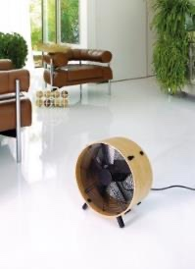
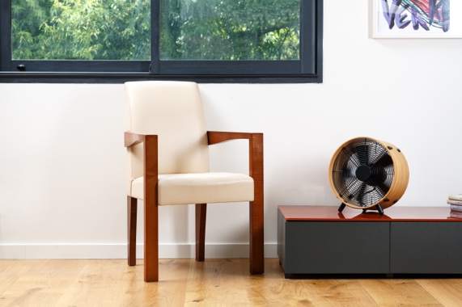
When the heat inside becomes stifling in summer, every breath of fresh air is a welcome relief. Otto, the stylish floor-standing fan from Stadler Form combats heat with three power levels. The fan, which is placed on the floor, concentrates on circulating large volumes of air. For Otto to achieve the best results he needs some space around him. The protective grille on the back can be removed for easy cleaning of the fan blades. Otto’s outstanding feature is the bamboo frame which creates a natural aesthetic.
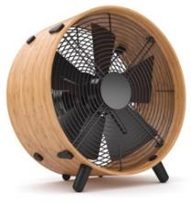

Fan Otto from Stadler Form, current webshop price CHF 179.00

3D fan Leo: for fans of exciting furnishing

In need of all-round cooling? That is just the job for Leo from Stadler Form. His 3D oscillation mode provides all-round air distribution. With a range of up to eight metres, the fresh breeze will reach everyone in the room. He can circulate the air flow vertically or horizontally at different adjustable angles. His various speed settings meet every need – from a slight breeze to strong gusts of wind. Leo has already received two awards for his advanced technology and stylish design, the European Product Design Award and the Good Design Award. The fan is mobile, has a small footprint and looks stylish. Thanks to the practical carrying handle he can easily be moved to his desired location. Whether it’s on a stool, table or sideboard, Leo can be placed at various places at home. He is also a star because of his timer and remote control that can be magnetically attached to his side.

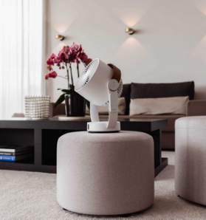
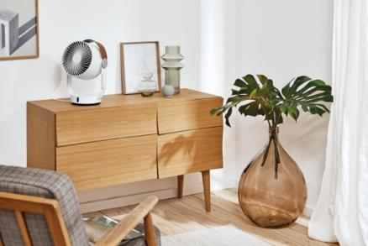
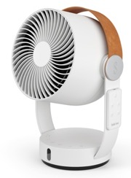

Fan Leo from Stadler Form, current webshop price CHF 129.00
Click here for Stadler Form’s YouTube video

Peter the tower fan: for fans of a minimalist design

Slim and elegant – Stadler Form’s tower fan Peter distributes the air evenly and pleasantly throughout the indoor space. Thanks to his column shape, Peter takes up little space and can be used even if the space condition is tight. The fan is available in black, white and leatherette. He can thus be easily matched to the interior. He is also a winner because of his intelligent functions, such as a natural breeze mode which simulates natural wind conditions. A remote control makes him easy to use. The speed setting for the desired wind speed can be conveniently controlled from your office chair, from the couch or from the bed to create a cool atmosphere. Peter combines design and functionality and has won the German Design Award for this.

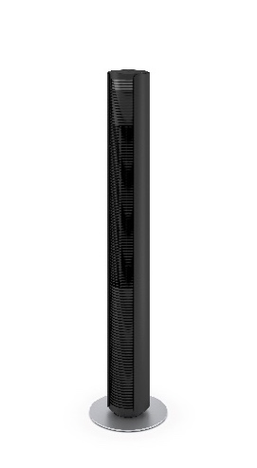
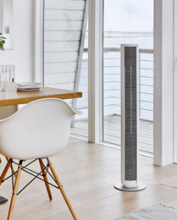
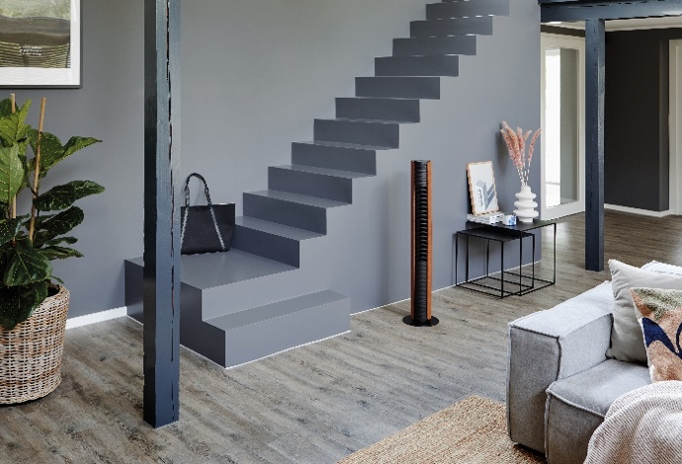

Fan Peter from Stadler Form, current webshop price CHF 189.00

Simon, the 3D fan: for fans of designer furnishings

Fan Simon from Stadler Form is a designer’s favourite. His textile cover makes a real visual statement and he fits perfectly into the home. Simon is not only stylish, he also impresses with his powerful performance and silent mode. For these reasons he received the Good Design Award in 2022. As soon as he is switched on, the top moves horizontally and vertically in both directions. As a result, the 3D oscillation circulates the air around the room perfectly at a distance of up to 10 metres. Another outstanding feature is that the settings can be changed comfortably from the couch using the magnetic radio remote control.
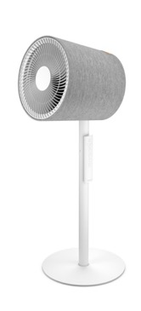
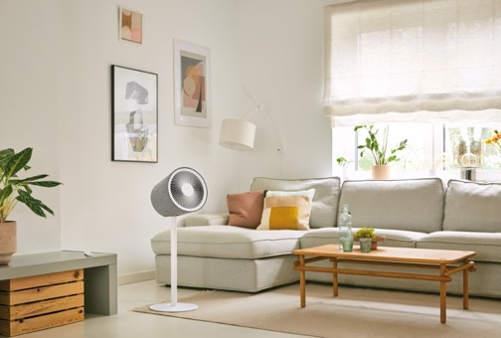

Fan Simon from Stadler Form, current webshop price CHF 239.00
Click here to watch Stadler Form’s YouTube video

The fans Otto, Leo, Peter and Simon by Stadler Form are available on stadlerform.com and at selected specialist retailers, as well as their online shops.

Please do not hesitate to contact us for further information.

Media contact

Silvia Acerra
Flowcube Communications | E-mail: silvia.acerra@flowcube.ch | Tel. +41 (0)43 344 30 35

