TRENDLETTER I Winter 2025

Gift ideas with personality

Stadler Form presents fragrant gift ideas for Christmas
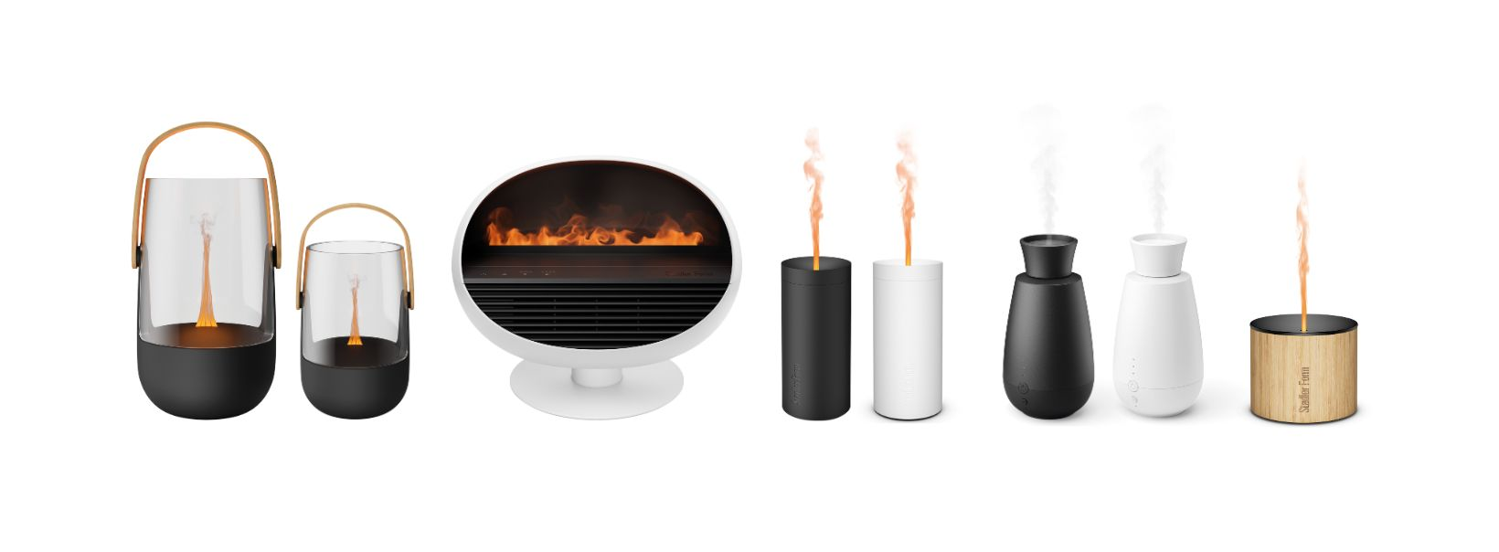
Christmas is a time for personal gifts – individual, stylish, and chosen with love. Stadler Form combines cutting-edge technology with high-quality design to offer the perfect present for every personality: elegant, versatile, romantic, clever or natural. Whether for moments of relaxation, festive ambience or a touch of technical sophistication – Stadler Form products make the holiday season truly special.

The elegant Sophie & Sophie little

A gentle flicker in warm Amber Light™ and a fine mist of fragrance that spreads almost silently through the room – Sophie and Sophie little create an atmosphere full of elegance and warmth. As a stylish combination of aroma diffuser and lantern, they transform living rooms, bedrooms or balconies into cosy little retreats. Their minimalist design and bamboo handle make them charming interior accessories – as practical as they are beautiful. The perfect gift for design lovers who seek elegant moments and relaxation during the winter and festive season.

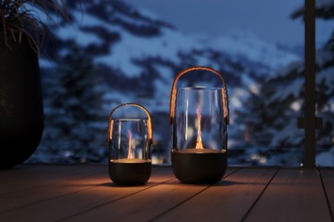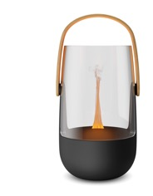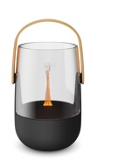

Aroma diffuser Sophie from Stadler Form, current webshop price Fr. 89.-
Aroma diffuser Sophie little from Stadler Form, current webshop price Fr. 74.90

The versatile Erik

For anyone who appreciates the charm of a flickering fire, gentle fragrance and soothing warmth, Erik is the perfect gift. This modern 3-in-1 device combines fan heater, electric fireplace and aroma diffuser – delivering warmth, scent and atmosphere in one. His flame effect doesn’t just glow in classic amber, but also offers red, blue or green – making Erik a real eye-catcher. With a digital thermostat and the option to diffuse essential oils, Erik brings together comfort and ambience in a single, stylish appliance.

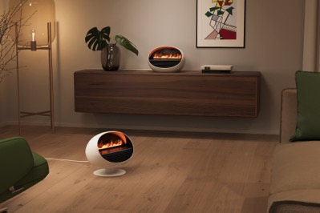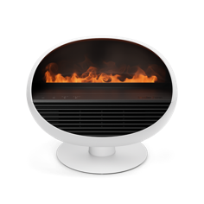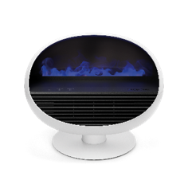

Fan heater Erik from Stadler Form, current webshop price Fr. 129.-

The romantic Lucy

A romantic candle-light dinner? Lucy makes it possible. Her realistic candlelight provides a cosy, atmospheric glow – without any open flame, heat or soot. A safe alternative to traditional candles, she creates a warm and inviting ambiance for any occasion. Lucy isn’t just perfect for setting the mood at the dinner table – she’s equally at home in the living room and bedroom. And if desired, she can gently fill the air with fragrance too: using ultrasonic technology, she diffuses essential oils as a soft, fine mist throughout the room. Thanks to her rechargeable battery, Lucy can be placed wherever you like and offers up to seven hours of light – with or without scent. The perfect gift for anyone who loves simple design, safety, and romantic moments.

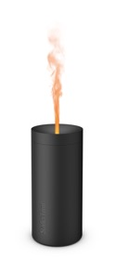
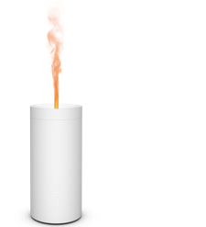
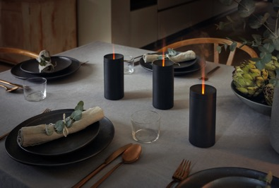

Aroma diffuser Lucy black from Stadler Form, current webshop price Fr. 39.90
Aroma diffuser Lucy white from Stadler Form, current webshop price Fr. 40.-

The clever Ella

A touch of winter magic for the senses: Ella, the innovative fragrance spray system, fills your home with fine essential oils – straight from the bottle and completely water-free. Her built-in light sensor automatically switches her on or off depending on the brightness of the room, while three intensity levels allow for personalised scent experiences. With a long-lasting battery that lasts approximately ten days, Ella offers maximum flexibility wherever you place her. A perfect gift for anyone who appreciates smart technology and a sensual, atmospheric home.

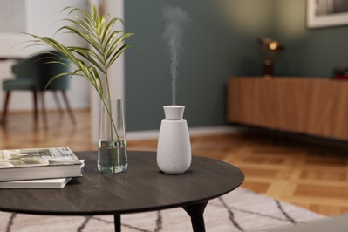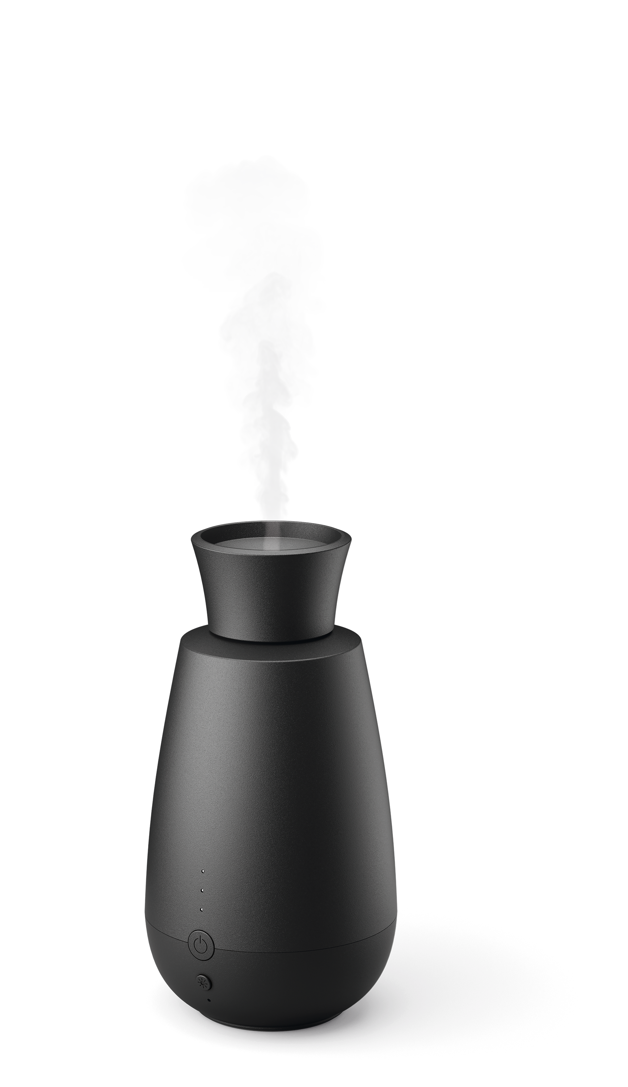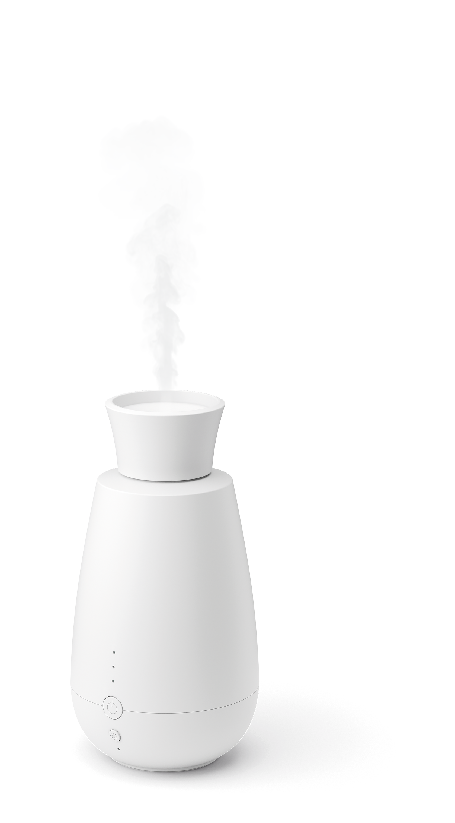

Aroma diffuser Ella black from Stadler Form, current webshop price Fr. 59.-
Aroma diffuser Ella white from Stadler Form, current webshop price Fr. 59.-

The natural Nora

Nora brings together natural materials like bamboo and high-end aluminium in a stylish design that blends effortlessly into any home. Her warm amber flame effect creates a cosy, soot-free candlelight atmosphere – perfect for peaceful moments, both indoors and out. Whether one is reading, dining, or simply by adding a decorative touch to your living space, Nora sets the scene with a sense of calm and comfort. She’s the ideal gift for anyone who values natural beauty, thoughtful design, and a home filled with special moments.

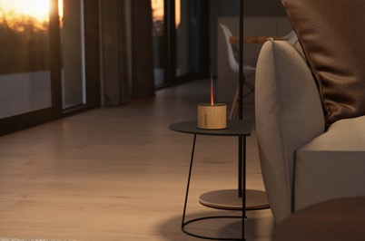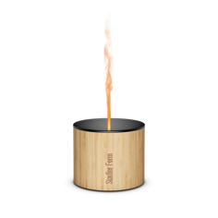

Aroma diffuser Nora from Stadler Form, current webshop price Fr. 65.90

The soothing Essential Oils Fireplace, Retreat and Relax

Stadler Form’s essential oils are 100 % natural, sustainably produced, and free from synthetic additives. The new Fireplace oil blend, with cedarwood and eucalyptus, brings the cosy charm of a mountain chalet and the feeling of sitting by a crackling fire into your home. Retreat, with orange and clove, evokes warm and comforting evenings, while Relax, with lavender and cedarwood, has a calming and soothing effect. In addition to these three, Stadler Form offers a wide range of essential oils to suit different moods and needs. These oils are the perfect complement to any aroma diffuser – and an inspiring gift idea for the festive season.

The aroma diffuser Sophie and Sophie little, Lucy, Ella & Nora and the fan heater Erik by Stadler Form are available on stadlerform.com and in selected specialist shops and their online shops.

Please do not hesitate to contact us for further information.

Media contact

Silvia Acerra
Flowcube Communications | E-Mail: silvia.acerra@flowcube.ch | | Tel. +41 (0)43 344 30 35

