PRESS RELEASE I February 2024

Smart, efficient and safe drying
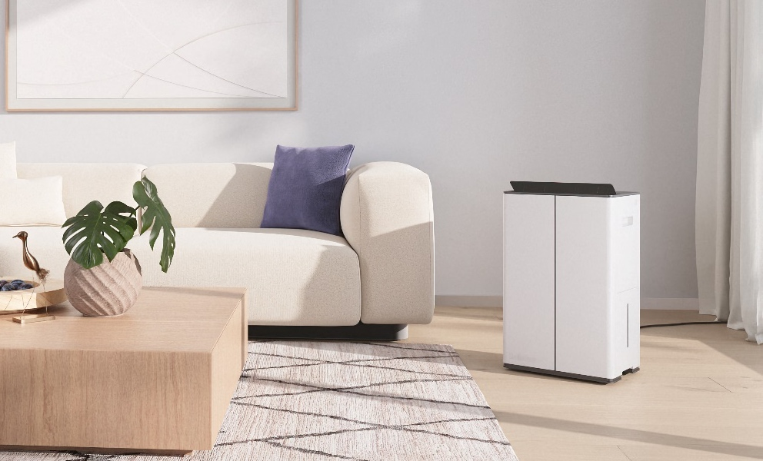
Stadler Form presents the new dehumidifier Lukas
The right indoor climate plays a crucial role in your well-being at home. If the humidity is too high, this encourages the formation of mould. Allergy and asthma symptoms are exacerbated, and you feel tired more quickly. A dehumidifier counteracts this by reducing the humidity level to an optimum level. Stadler Form launches the powerful and intelligent roommate Lukas on 15 February 2024. Equipped with Wi-Fi as well as a night and laundry drying mode, he ensures dry rooms and clothes in no time at all.
"We are very proud to launch Lukas as the newest member of the Stadler Form family. Together with the Swiss product designer Matti Walker, our aim was not only to develop a powerful and beautifully designed dehumidifier, but also to integrate intelligent functions that meet the individual and diverse needs of our customers. Thanks to his modern design, Lukas also blends harmoniously into any room ambience," explains Stadler Form CEO Martin Stadler.

The new dehumidifier from Stadler Form is characterised by the following special features

- Wi-Fi function: operate Lukas easily from anywhere
Do you want to prepare the ideal indoor climate in your own four walls, laundry room or hobby room while you're at work or travelling home? No problem for Lukas. The four dehumidification levels and the digital hygrostat, which ensure a precise and customised humidity setting, can be monitored and controlled either via the touch panel with digital display or via the Stadler Form app. For the latter, Lukas only needs to be connected to the relevant Wi-Fi. All other functions, such as the swing function, which distributes the air evenly throughout the room, or the child safety lock, which deactivates all buttons on Lukas, can also be set via the app. The user-friendly smartphone app enables simple operation.
- Mode for quick drying: gentle for clothes and other textiles
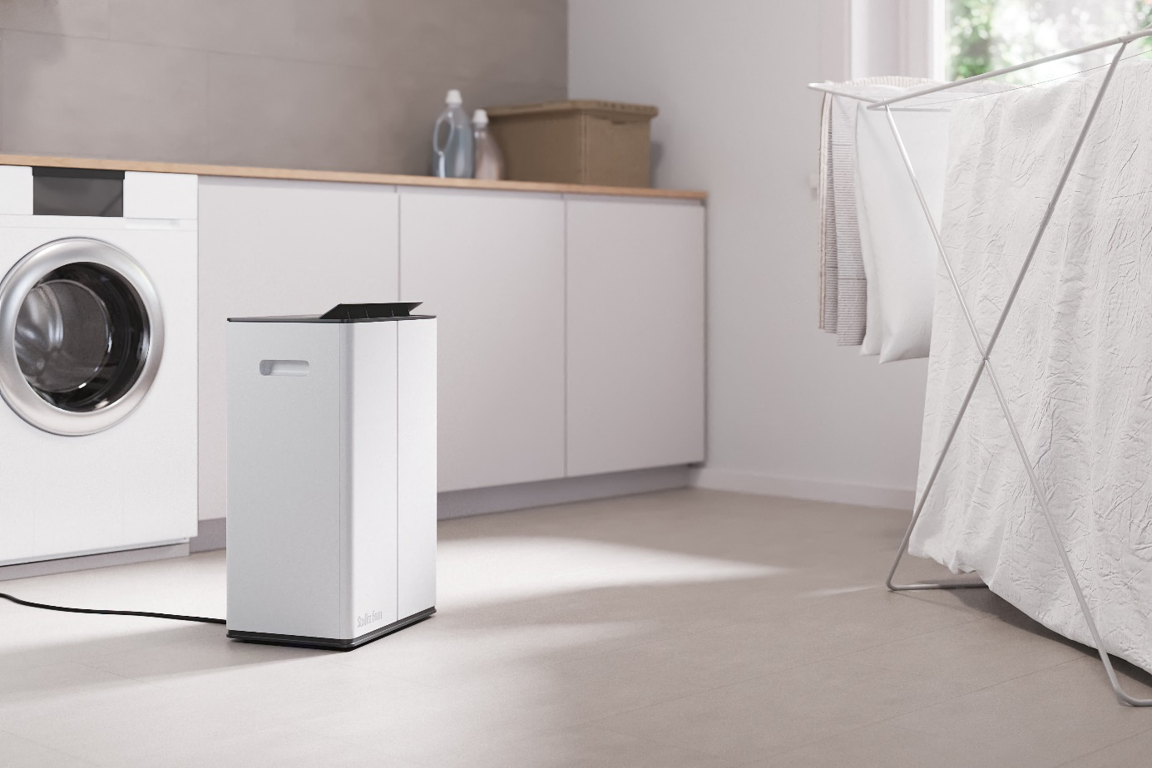
Lukas is also a helpful and powerful roommate when it comes to drying laundry. With the special laundry drying mode, clothes and other textiles can be put back in the wardrobe more quickly. It also ensures gentle and careful drying, resulting in less wear and tear on clothes. You also don't have to worry about where to dry your laundry with Lukas. Thanks to the carrying handles on the side and hidden transport wheels, he can be moved anywhere quickly and easily.

- Night mode: quieter operation and dimmed LEDs

In night mode, Lukas does his job unobtrusively by setting the operating level to 1 and dimming the LEDs. Ideal for avoiding noises from the cellar or through walls while you sleep.

- 2-in-1 function: with a HEPA filter, Lukas cleans the air at the same time

A HEPA filter, which can be used to remove particles from the air, is available as an optional accessory. This turns Lukas into a dehumidifier and air purifier, which also filters fine dust, allergens, smoke particles and other pollutants in no time at all. This 2-1 combination ensures the highest air quality in the rooms.
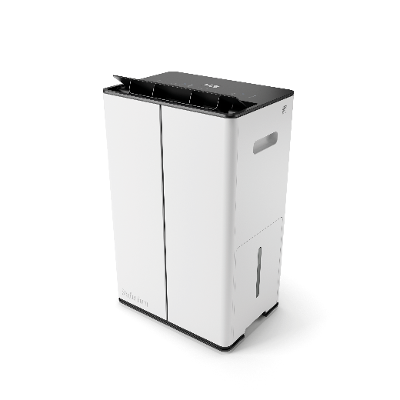
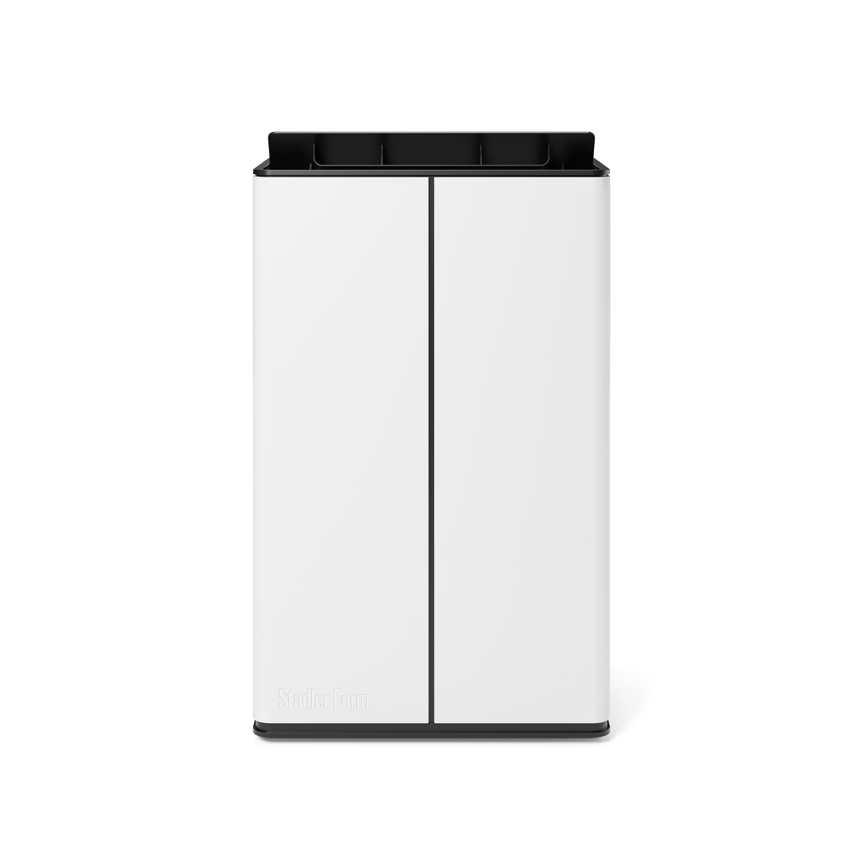

Lukas from Stadler Form, suitable for rooms up to 70 m², current webshop price, CHF 399.-

Lukas by Stadler Form will be available from 15 February 2024 at stadlerform.com and in selected specialist shops and their online shops.

Please do not hesitate to contact us for further information.

Media contact

Silvia Acerra
Flowcube Communications AG | E-Mail: silvia.acerra@flowcube.ch | Tel. +41 (0)43 344 30 35

