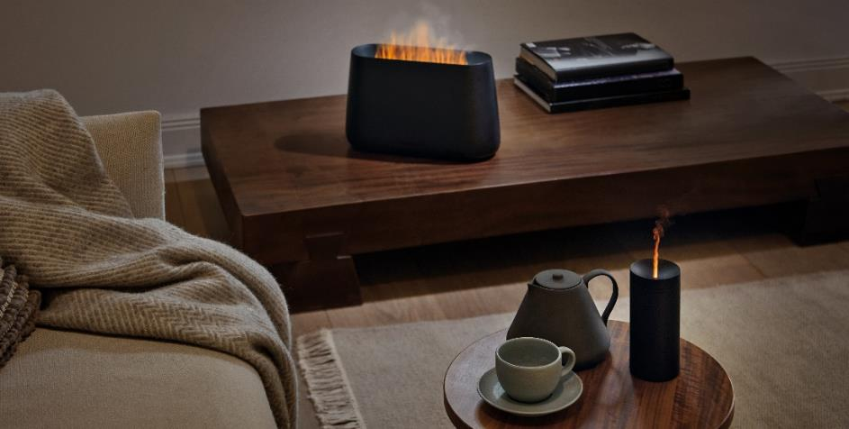
PRESS RELEASE I Autumn 2021

Multi-talent for three pleasures for the senses

Stadler Form presents 3-in-1 room accessory Ben

The days are getting shorter and the nights are getting cooler. In autumn and winter, we long for a cosy home even more. Even if you haven’t got a fireplace, this innovative product from Stadler Form can create the feel-good atmosphere of an open fire in your living room. Stadler Form – a brand for intelligent air solutions – is launching elegant humidifier Ben on 26 October. With his amber light, the 3-in-1 talent not only creates a cosy ambience but also humidifies and fragrances the indoor air at the same time.

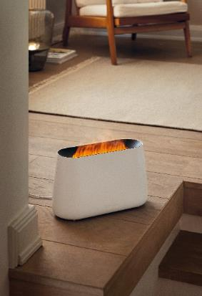
Lean back, take a deep breath and feel good: with Ben, you can do just that. His multi-functionality can instantly transform any home into an oasis of well-being.

Has turning the central heating on made the air dry? No problem: Ben’s fine mist will produce the humidity you need. A tip for fans of essential oils: if you wish, you can add essential oils to Ben so that he emits a gentle fragrance and creates a cosy atmosphere by bathing the room in a warm light, without the need for candles.

In Ben, Stadler Form has created 3 talents in 1 and this technical innovation is to be launched in autumn 2021: a humidifier, aroma diffuser and fireplace effect in one – a real pleasure for the senses.

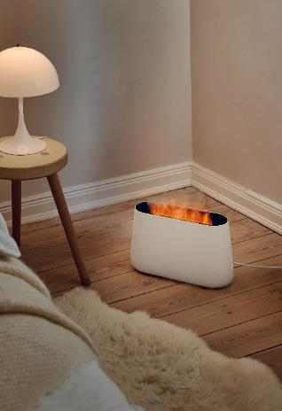
You will need to choose the right location to show off the fragrant flickering flame to its best advantage. Thanks to his handy size however, you can move Ben around whenever you wish.

For the multi-talented device to be able to exhibit his three skills, he will need to be filled with water first, to which a couple of drops of essential oil can be added if required. Stadler Form has five natural oil mixtures for you to choose from: Recharge, Relief, Refresh, Relax and Revive.

The pleasant aroma is silently emitted into the room as fine mist while the Amber LightTM produces a remarkably realistic flickering flame, without any fire hazard or soot for you to worry about. You can also steplessly adjust the intensity from a gentle flame to a small open fire. Particularly practical: the 2.5-litre removable water tank can be topped up while the device is being used.

The flame effect and illuminated water level indicator can be dimmed or switched off altogether so you can get a well-earned good night’s sleep without being disturbed. So let Ben transform your home into a place to relax, day in and day out.

Ben from Stadler Form, current market price Fr. 129,00

Multi-talented Ben from Stadler Form is available from 26 October 2021 at stadlerform.com and from selected specialist stores and their online shops.

The 100% natural essential oils made in Switzerland can be purchased separately.

Please do not hesitate to contact us for further information.

Press contact:
Valeria Happel
Flowcube Communications | E-mail: valeria.happel@flowcube.ch | Tel. +41 (0)43 344 30 37

