TRENDLETTER I Autumn 2025

Take a deep breath and feel good

Stadler Form presents humidifiers and air washers for a healthy indoor climate

Dry air can noticeably affect your well-being – it irritates the respiratory tract, dries out the skin and makes you feel tired. Stadler Form, the Swiss specialist in air treatment, develops beautifully designed appliances that promote a healthy indoor environment while meeting the highest standards of functionality and aesthetics. Whether it's energy-efficient evaporators like Oskar and Karl, a compact ultrasonic humidifier like Oliver, or a 2-in-1 air washer like George – each model combines technical innovation with timeless design, offering the ideal solution for different room sizes and individual needs.

Oskar – timeless design for various room sizes

Suitable for: bedrooms, children’s rooms and smaller workspaces. Ideal wherever quiet operation, a small footprint and comfortable humidity are needed.

The Oskar trio – Oskar little, Oskar, and Oskar big – quietly and efficiently provide optimal humidity. The built-in hygrostat, night mode and timeless design make Oskar the perfect companion for bedrooms, children’s rooms or workspaces. Depending on the room size, you can choose from three models – from the compact Oskar little for spaces up to 30 m², to the powerful Oskar big for large rooms up to 100 m². The energy-efficient evaporation principle humidifies the air naturally: it supplies only as much moisture as the air currently needs. The option to add essential oils also creates a pleasant, personalised fragrance.

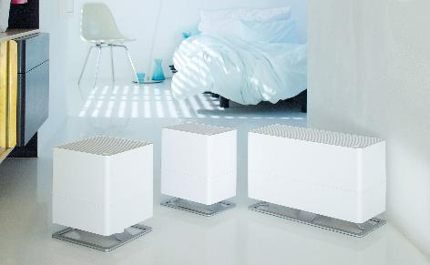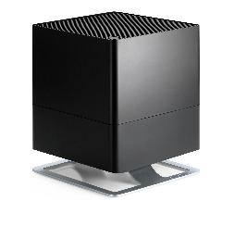

Humidifier Oskar from Stadler Form, current webshop price Fr. 128.-, available in black and white
Humidifier Oskar little von Stadler Form, current webshop price Fr. 84.90, available in black and white
Humidifier Oskar big von Stadler Form, current webshop price Fr. 189.-, available in black and white

Karl & Karl big – powerful performance for large rooms

Suitable for: large living areas, open-plan spaces or spacious offices. Their high performance humidifies quickly and efficiently.

The two humidifiers, Karl and Karl big, impress with a strong performance while consuming minimal electricity. In auto mode, they independently select the appropriate humidification level, ensuring a quick and efficient creation of the ideal indoor climate. Karl is suitable for rooms up to 100 m², while Karl big covers areas up to 150 m². Both models can be conveniently controlled via the Stadler Form smartphone app, making all functions easily accessible at any time. Thanks to the anthracite textile cover and modern design, both models blend harmoniously into any environment.

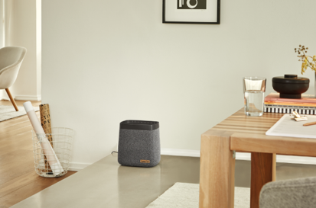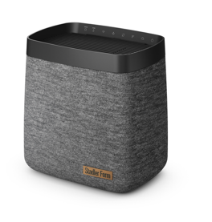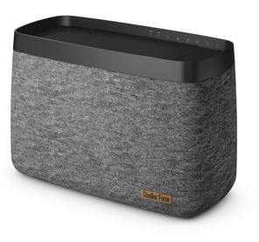

Humidifier Karl from Stadler Form, current webshop price Fr. 175.-
Humidifier Karl big from Stadler Form, current webshop price Fr. 269.-

Oliver – hygienic humidification made easy

Suitable for: medium-sized living or workspaces where hygienic humidification is desired.

Oliver, the new ultrasonic humidifier, provides rooms of up to 60 m² with moisture. Thanks to integrated UV technology, the water is disinfected so that the mist released into the air is free from bacteria, viruses and fungi. Depending on your preference, Oliver emits either warm or cool mist.
The Auto Mode with Adaptive Humidity™ automatically adjusts performance and maintains a constant desired humidity level – reliably and effortlessly. The tank can be comfortably refilled from the top, even during operation. Oliver also features a dedicated fragrance drawer to add a subtle, pleasant scent to the room. With his quiet operation and optional LED dimming, Oliver is also perfect for use in bedrooms.

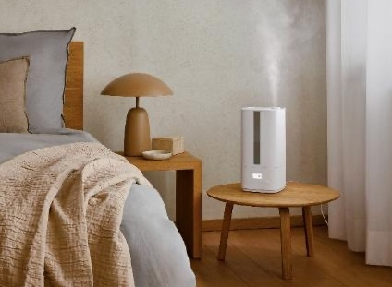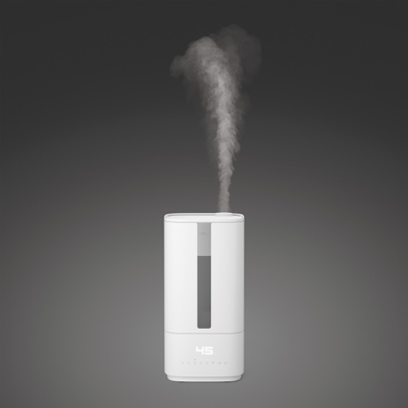

Ultrasonic humidifier Oliver from Stadler Form, current webshop price Fr. 109.-, available in black and white

George – humidifying and purifying in one

Suitable for: living rooms, bedrooms or workspaces up to 60 m² where clean, allergy-friendly air and balanced humidity are essential.

George combines humidification and air purification in one device, functioning as an air washer. Discs rotating in water reliably remove particles, fine dust and unpleasant odours – a real benefit for allergy sufferers. The integrated fragrance container allows you to enhance the air with essential oils for a pleasant atmosphere. The auto mode with hygrostat keeps humidity at the desired level – energy-efficient and hassle-free. Both the disc pack and water tray are dishwasher-safe, making cleaning particularly easy.

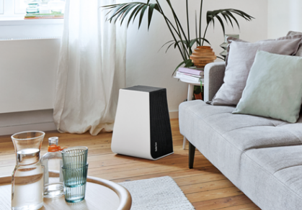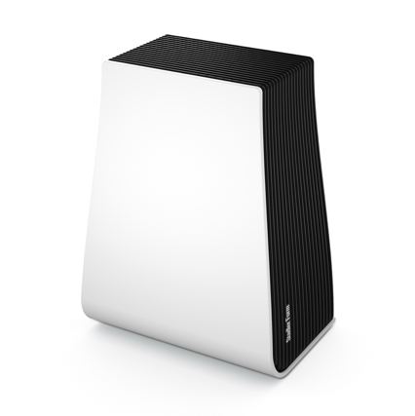

Air washer George from Stadler Form, current webshop price Fr. 199.-

The evaporators Karl and Karl big, Oskar, Oskar little and Oskar big, the new ultrasonic humidifier Oliver, as well as the air washer George by Stadler Form are available on stadlerform.com and in
selected specialist shops and their online shops.
Please do not hesitate to contact us for further information.
Press contact

Silvia Acerra
Flowcube Communications | E-Mail: silvia.acerra@flowcube.ch | Tel. +41 (0)43 344 30 35

