TRENDLETTER I Autumn & Winter 2023

Five gift ideas for Christmas
Stadler Form presents stylish aroma diffusers with flame effect
The pre-Christmas season will soon be here and with it the search for the ideal gift begins. With the aroma diffusers from Stadler Form, you don't just give your loved ones a design object, but relaxation and time for themselves – still the most precious of all gifts. Thanks to their innovative technology, Sophie, Sophie little, Ben, Lucy, Zoe and Nora create a unique light and fragrance ambience and thus ensure moments of well-being at home.

Gift idea #1: Sophie & Sophie little, the 2-in-1 aroma diffusers and lanterns

Cosy play of light for indoors and outdoors, and with a fine fragrance to top it all off. Sophie and Sophie little by Stadler Form inspire with their multifunctionality: They are aroma diffuser and lantern in one and can be placed indoors or outdoors. Thanks to their stylish design with a noble bamboo handle, Sophie and Sophie little are real eye-catchers. The amber-coloured Amber LightTM creates an atmospheric play of flames, and the desired fragrance is distributed silently as a fine mist using ultrasound technology.

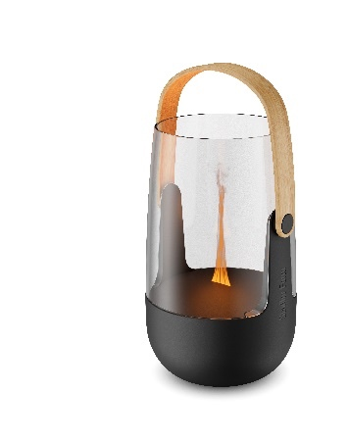
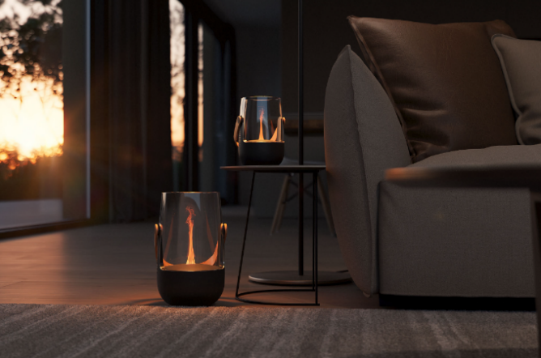
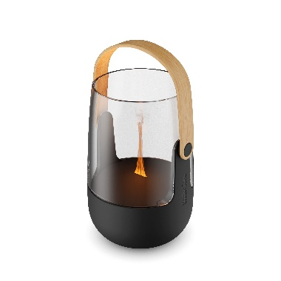

Aroma Diffuser Sophie from Stadler Form, current webshop price Fr. 99.-
Aroma Diffuser Sophie little from Stadler Form, current webshop price Fr. 79.-

Gift idea #2: Ben, the 3-in-1 aroma diffuser, humidifier and effect fire

Sit back and breathe deeply: The multifunctional Ben by Stadler Form creates a cosy atmosphere, humidifies the room air and emanates a pleasant fragrance. Even without a fireplace, thanks to Ben you can enjoy a cosy fireside feeling. The amber-coloured Amber Light™ ensures a fire- and soot-free play of flames. The intensity can be regulated from a gentle flame to a fascinating open fire. Thanks to his handy size, Ben can be placed anywhere in the house.

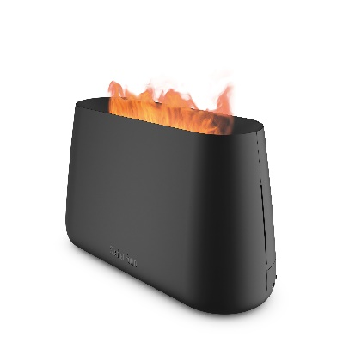
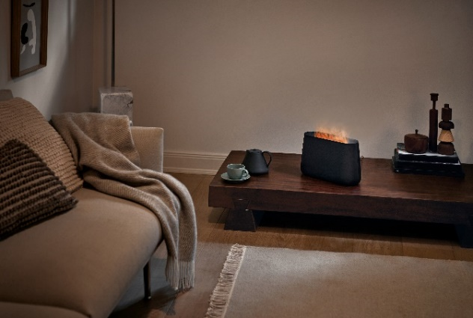

Ben from Stadler Form, in black and white, current webshop price Fr. 109.-

Gift idea #3: Lucy, the glowing aroma diffuser lady

Lucy immerses the room in soft light and fills it with a subtle scent of essential oils using nebuliser technology. She can be placed anywhere thanks to her rechargeable battery. The deceptively real candlelight ensures cosy hours and soothing relaxation. Thanks to the atmospheric flame effect and a selection of versatile aromas, Lucy is an indispensable companion on winter evenings.
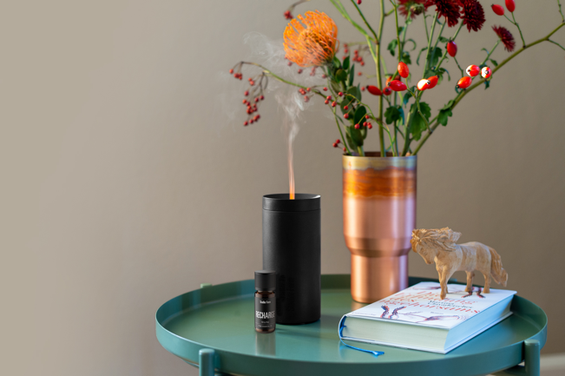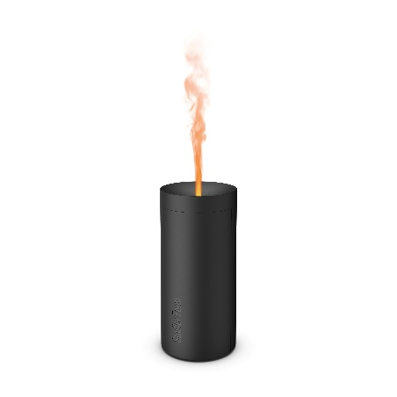

Aroma Diffuser Lucy from Stadler Form, in black and white, current webshop price Fr. 49.-

Gift idea #4: Zoe, the glamorous aroma diffuser lady

Zoe by Stadler Form transforms any room into an oasis of well-being. Fine mist emanates from the bronze-coloured bowl in an elegant metal look and the Amber Light™ creates an amber-coloured play of flames. The fragrance is distributed optimally and energy-efficiently within your own four walls at the touch of a button.
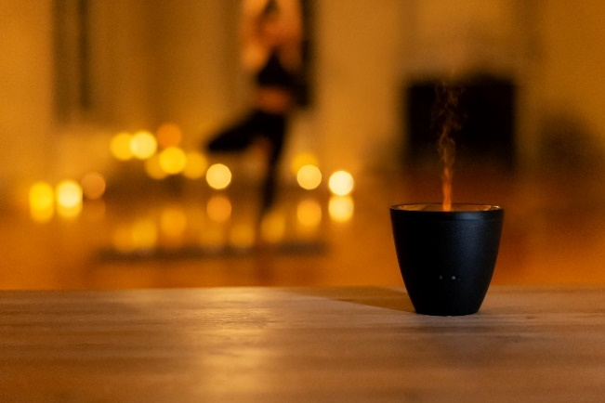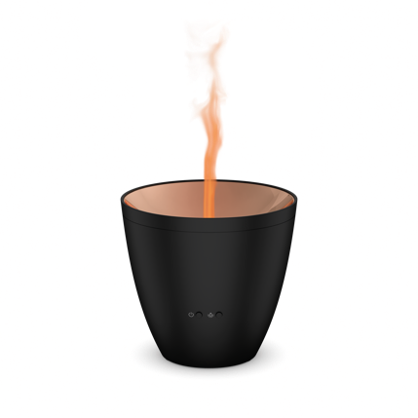

Aroma Diffuser Zoe from Stadler Form, in black and white, current webshop price Fr. 59.-

Gift idea #5: Nora, the elegant aroma diffuser lady

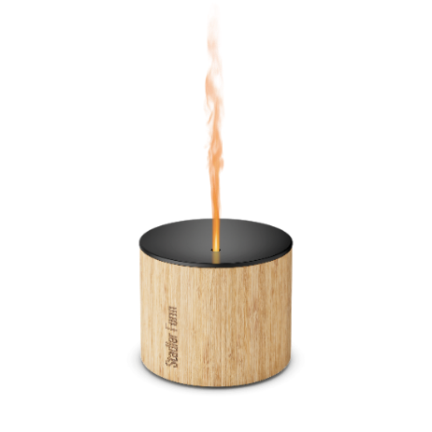
Natural bamboo and high-quality aluminium make Nora, the newest member of the Stadler Form family, more than just an aroma diffuser. The elegant design fits perfectly on a beautifully set table and ensures a romantic, soot-free candlelight dinner. Thanks to the splash-proof function, Nora creates a cosy atmosphere indoors or in a covered outdoor area. The battery lasts up to 7 hours, which is why Nora also embellishes longer autumn or winter evenings.
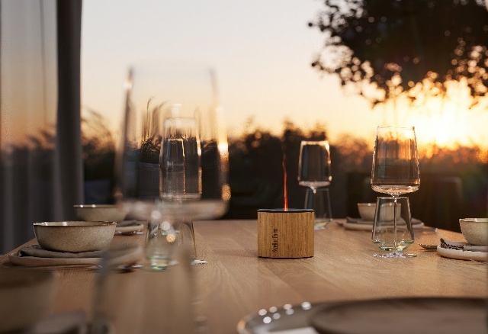

Aroma Diffuser Nora by Stadler Form, current webshop price Fr. 79.-

All products are ready for use in three simple steps

- Fill the water up to the mark
- Add a few drops of the desired essential oil
- Switch on and relax

There are five different natural essential oil blends from Stadler Form to choose from for the gift ideas: Recharge, Refresh, Relax, Relief and Repel.

Sophie, Sophie little, Ben, Lucy, Zoe and Nora by Stadler Form are available at stadlerform.com and in selected specialist shops and their online shops.

Please do not hesitate to contact us for further information.

Press contact
Silvia Acerra
Flowcube Communications | E-Mail: silvia.acerra@flowcube.ch | Tel. +41 (0)43 344 30 35

